**Sales order and Customer Balance services instruction**

1. **Run IIS manager and find the MicrosoftDynamicsAif50 site and explore its file and make a backup its entire files. Also you need to stop WWW service.**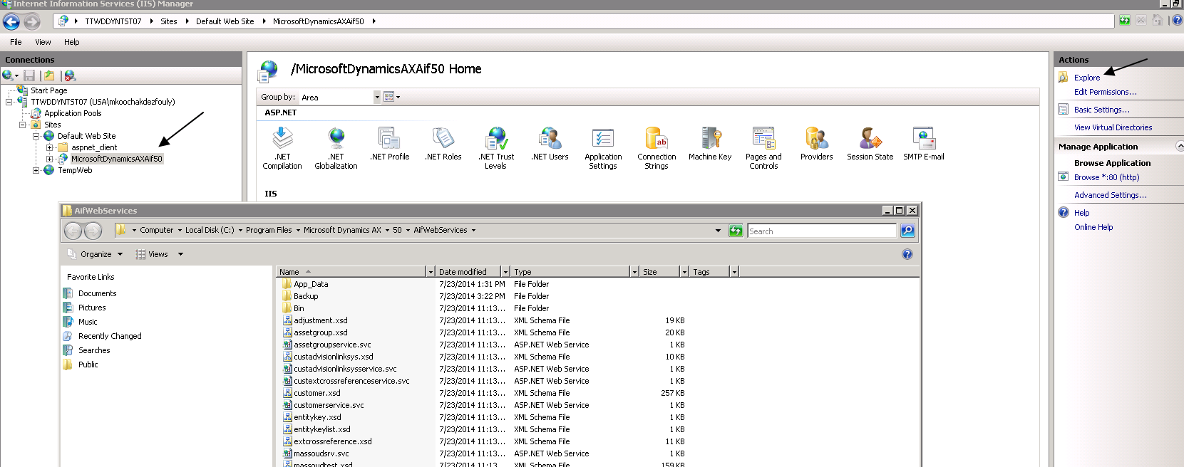
2. **Go to AX->Basic->setup-> Application Integration Framework->services and click refresh to add new TrbAXService. It takes few minutes to be refreshed. Then find the services as below You need to check both SalesSalesOrderService and TrbAXService should be found and be enabled. Then click generate button to generate IIS service files.**

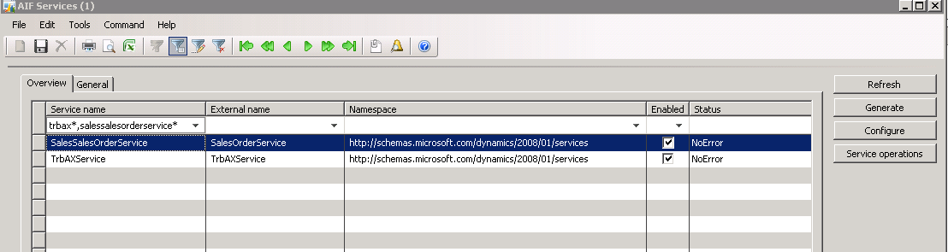

1. **Find the SalesSalesOrderService in above form and click configure button. It should be same as below screen, if it is not change the binding as below: should have WsHttpBinding. If it is BasicBinding please change it to WsHttpBinding, and save the changes by clicking yes button when prompted and click generate button from the above form again.**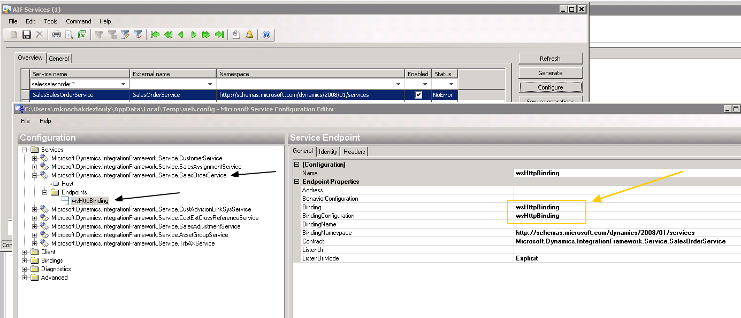
2. **And configuration for TrbAXService should be BasicHttpBinding as below**

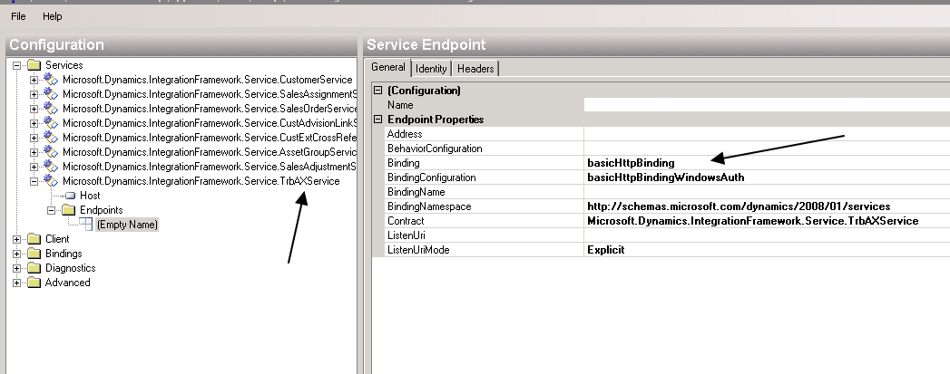

1. **You need to run job AifDataPolicy_SalesSalesOrder_AllCompany in AX project JIRA_PEAX1830_AddSalesNote2AIF. You should not get any error when you run the job.**
2. **From this step you need to repeat all below steps for all BU(companies). From top menu select a company (except DAT company. We don’t need DAT company)**

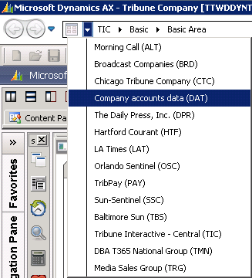

1. **In AX->Basic->setup-> Application Integration Framework->endpoint form and click on Action Policy button, find SalesSalesOrderService* as below. We should have 6 different actions for this service and only delete and findkey actions should have selected “Is default policy” check box, if not then run job AifDataPolicy_SalesSalesOrder in AX project JIRA_PEAX1830_AddSalesNote2AIF**

**. Keep this form open for another step.**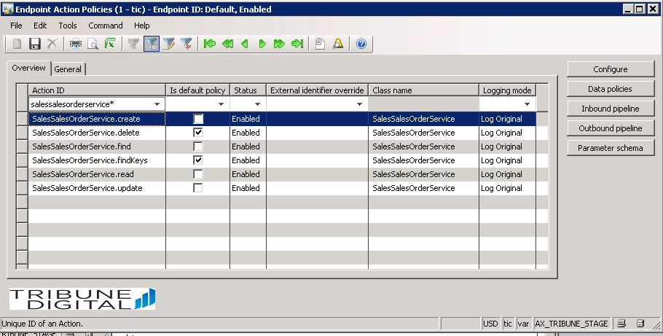

1. **Click on data policy button on above form(Endpoint action policies) to see below form and make sure filter it for InvoiceNotes field, it should be enabled but not required, otherwise then run job AifDataPolicy_SalesSalesOrder in AX project JIRA_PEAX1830_AddSalesNote2AIF**

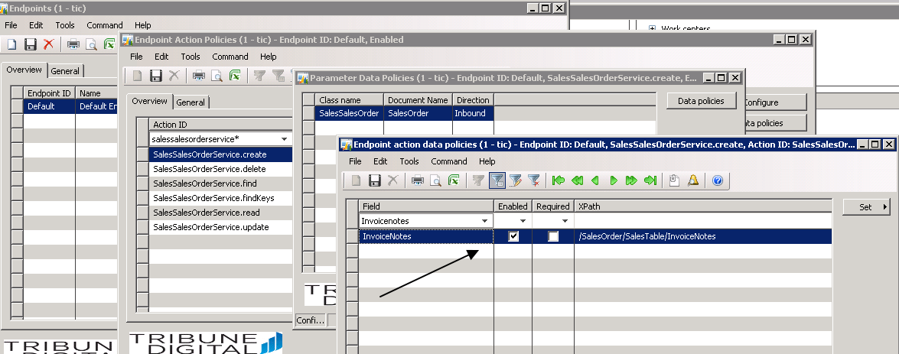

**And also filter it for required filed to have below fields:** 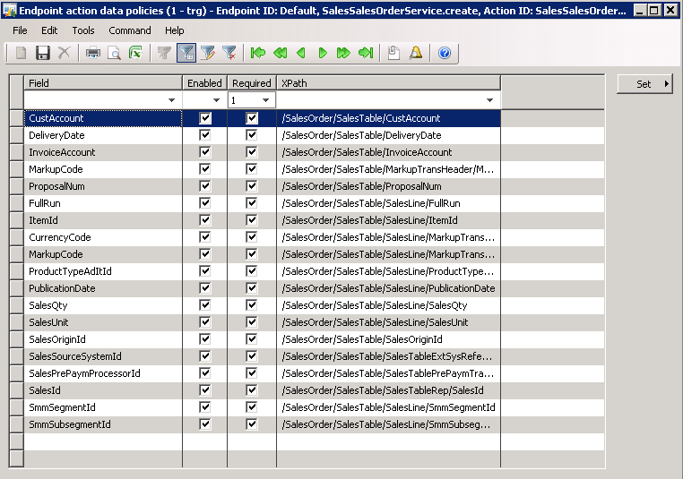

1. **Back to step 6 for another company(BU) but make sure to close all forms in AX otherwise it is hard to switch between companies.**
2. **In AX->Basic->setup->Application Integration Framework->web sites shows the MSMQ servers. (Below is from my AX QA and is not same as STAGE or PROD).**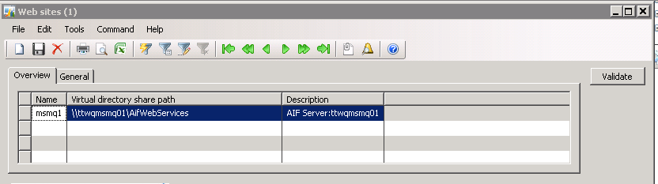

**Now all IIS files(in MSMQ servers) should be updated for services, to check that you need make sure the files are updated as deployment date, if not, means generate service in step 2 did not work and you need to redo it.**

1. **Copy AIFTest.exe file from \\xen02\AXFiles\AIF Smoke Test\QA1 LB to the smoke test folder regard to AX env you are deploying (Stage or Prod). And make sure in AIFTest.exe.config file, the service URL for the endpoints are referring to the Production MSMQ site.**
2. **Now is time to run IIS and SmokeTest. First try to create a new sales order for each BU(company) and go to AX sales order form and find the order and in general tab you need to see Invoice Notes as below. You need to do it for each company without any error.**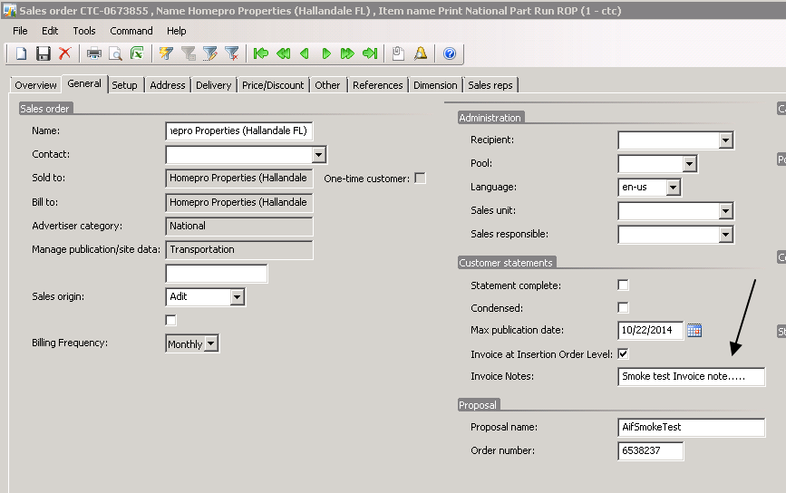

**13- Continue to run smoke test for quick test option (QT) to check other services.**